Problem 1. A point charge of magnitude +q produces an electric field pattern with a certain strength at distance r.
a) If another point charge produces an electric field that is twice as strong at the same distance r, what is the magnitude and sign of this second charge? (5 pts)
b) If a third point charge produces an electric field that is half as strong and directed inward at the same distance r, what is the magnitude and sign of this charge? (5 pts)

Problem 2.
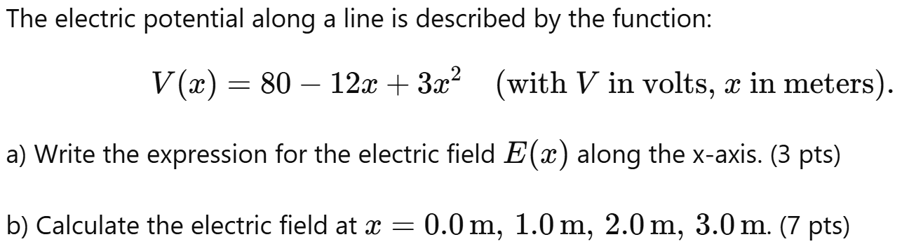

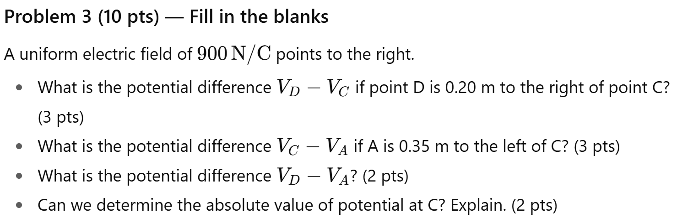
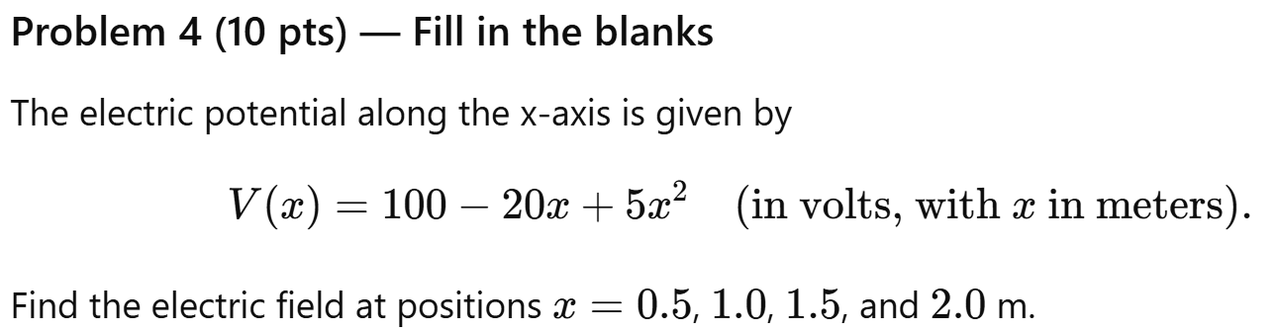
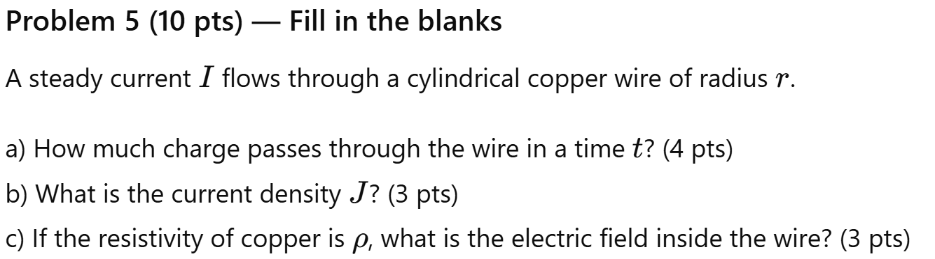

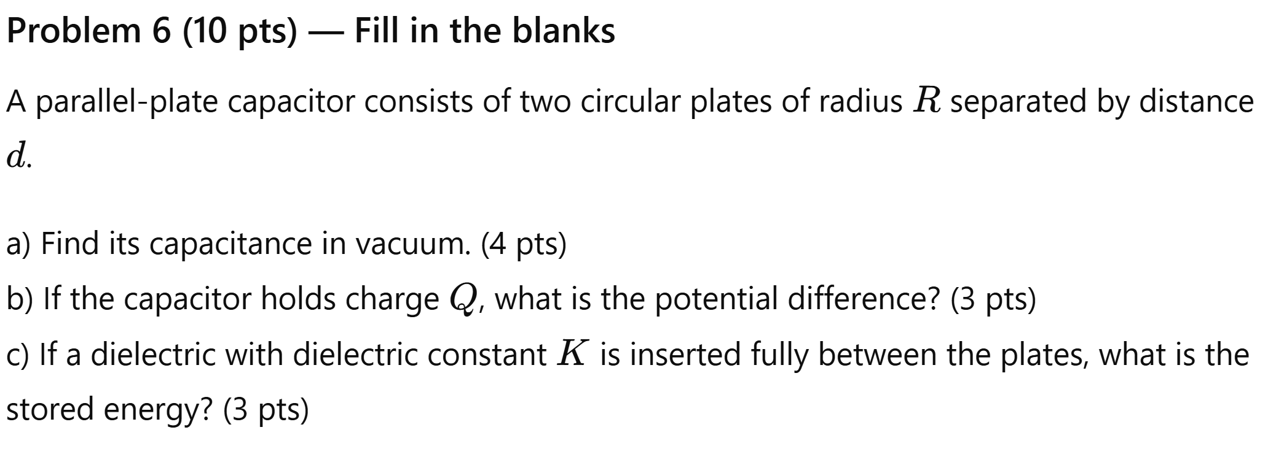
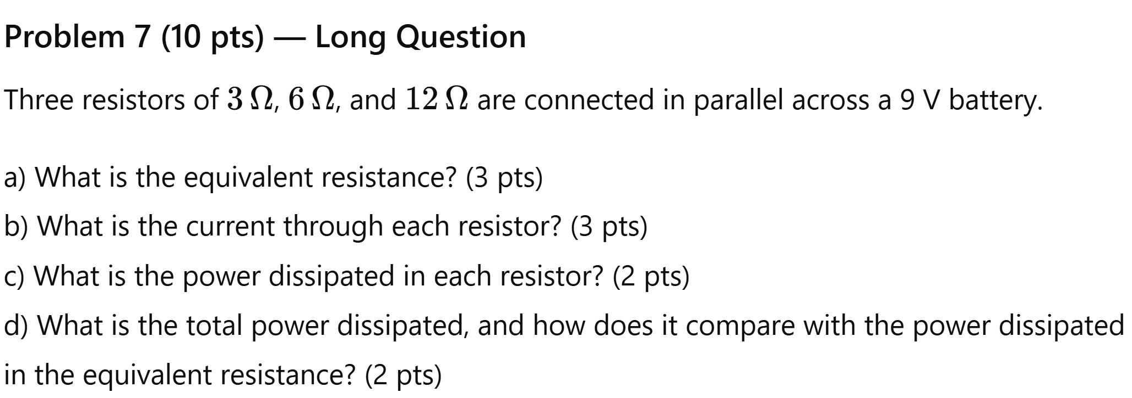
Problem 8 (10pts) Long question
